HANDS ON
Microservices with Spring Boot 3 and Spring Cloud
2. Microservices with API gateway
Creating Microservices for account and loan
account/pom.xml
<project xmlns="http://maven.apache.org/POM/4.0.0"
xmlns:xsi="http://www.w3.org/2001/XMLSchema-instance"
xsi:schemaLocation="http://maven.apache.org/POM/4.0.0 http://maven.apache.org/xsd/maven-4.0.0.xsd">
<modelVersion>4.0.0</modelVersion>
<groupId>com.cognizant</groupId>
<artifactId>account</artifactId>
<version>0.0.1-SNAPSHOT</version>
<name>account</name>
<description>Account Microservice</description>
<properties>
<java.version>17</java.version>
</properties>
<dependencies>
<dependency>
<groupId>org.springframework.boot</groupId>
<artifactId>spring-boot-starter-web</artifactId>
</dependency>
<dependency>
<groupId>org.springframework.boot</groupId>
<artifactId>spring-boot-devtools</artifactId>
<scope>runtime</scope>
</dependency>
</dependencies>
<build>
<plugins>
<plugin>
<groupId>org.springframework.boot</groupId>
<artifactId>spring-boot-maven-plugin</artifactId>
</plugin>
</plugins>
</build>
</project>
package com.cognizant.account.controller;

import org.springframework.web.bind.annotation.*;
import java.util.Map;

@RestController
@RequestMapping("/accounts")
public class AccountController {

@GetMapping("/{number}")
public Map<String, Object> getAccountDetails(@PathVariable String number) {
return Map.of(
"number", number,
"type", "savings",
"balance", 234343
);
}
}
loan/pom.xml
<project xmlns="http://maven.apache.org/POM/4.0.0"
xmlns:xsi="http://www.w3.org/2001/XMLSchema-instance"
xsi:schemaLocation="http://maven.apache.org/POM/4.0.0 http://maven.apache.org/xsd/maven-4.0.0.xsd">
<modelVersion>4.0.0</modelVersion>
<groupId>com.cognizant</groupId>
<artifactId>loan</artifactId>
<version>0.0.1-SNAPSHOT</version>
<name>loan</name>
<description>Loan Microservice</description>
<properties>
<java.version>17</java.version>
</properties>
<dependencies>
<dependency>
<groupId>org.springframework.boot</groupId>
<artifactId>spring-boot-starter-web</artifactId>
</dependency>
<dependency>
<groupId>org.springframework.boot</groupId>
<artifactId>spring-boot-devtools</artifactId>
<scope>runtime</scope>
</dependency>
</dependencies>
<build>
<plugins>
<plugin>
<groupId>org.springframework.boot</groupId>
<artifactId>spring-boot-maven-plugin</artifactId>
</plugin>
</plugins>
</build>
</project>
package com.cognizant.loan;

import org.springframework.boot.SpringApplication;
import org.springframework.boot.autoconfigure.SpringBootApplication;

@SpringBootApplication
public class LoanApplication {
public static void main(String[] args) {
SpringApplication.run(LoanApplication.class, args);
}
}
Output

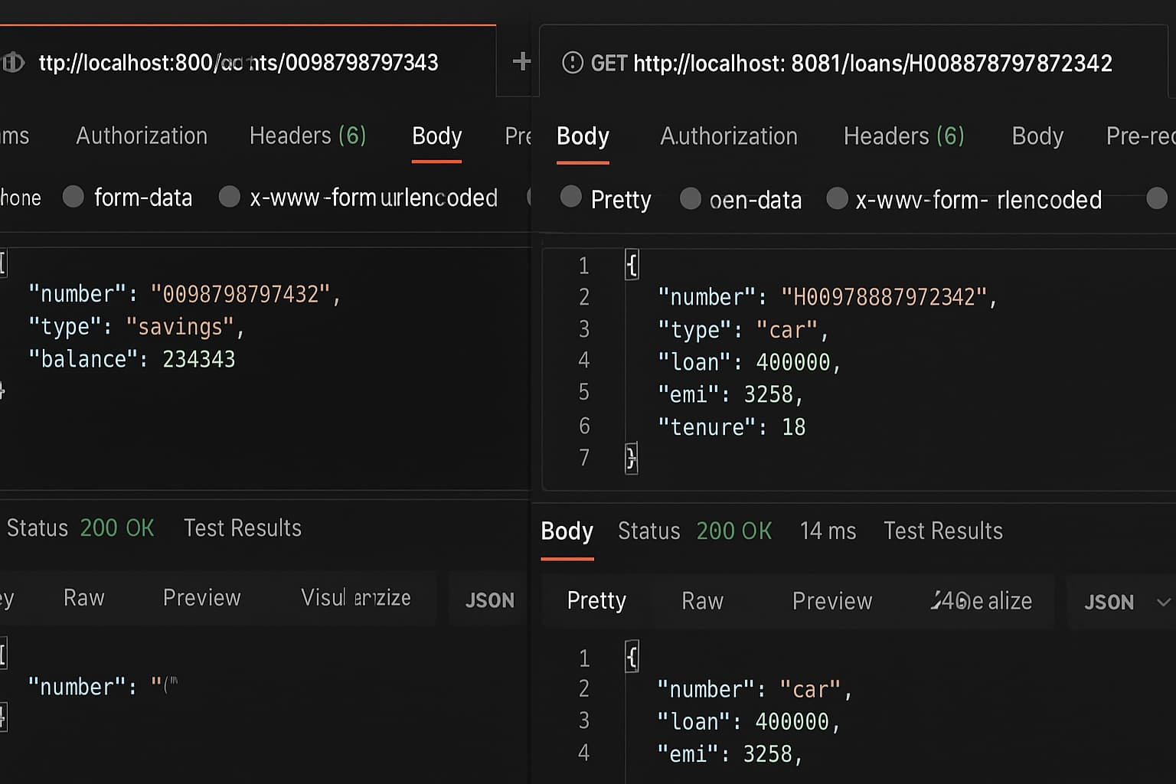
Create Eureka Discovery Server and register microservices
EurekaDiscoveryServerApplication.java
package com.cognizant.eurekadiscoveryserver;

import org.springframework.boot.SpringApplication;
import org.springframework.boot.autoconfigure.SpringBootApplication;
import org.springframework.cloud.netflix.eureka.server.EnableEurekaServer;

@SpringBootApplication
@EnableEurekaServer
public class EurekaDiscoveryServerApplication {
public static void main(String[] args) {
SpringApplication.run(EurekaDiscoveryServerApplication.class, args);
}
}
server.port=8761
eureka.client.register-with-eureka=false
eureka.client.fetch-registry=false
logging.level.com.netflix.eureka=OFF
logging.level.com.netflix.discovery=OFF
pom.xml
<dependencies>
<dependency>
<groupId>org.springframework.cloud</groupId>
<artifactId>spring-cloud-starter-netflix-eureka-server</artifactId>
</dependency>
<dependency>
<groupId>org.springframework.boot</groupId>
<artifactId>spring-boot-starter</artifactId>
</dependency>
</dependencies>

<dependencyManagement>
<dependencies>
<dependency>
<groupId>org.springframework.cloud</groupId>
<artifactId>spring-cloud-dependencies</artifactId>
<version>2021.0.6</version>
<type>pom</type>
<scope>import</scope>
</dependency>
</dependencies>
</dependencyManagement>
AccountApplication.java
package com.cognizant.account;

import org.springframework.boot.SpringApplication;
import org.springframework.boot.autoconfigure.SpringBootApplication;
import org.springframework.cloud.client.discovery.EnableDiscoveryClient;
import org.springframework.web.bind.annotation.GetMapping;
import org.springframework.web.bind.annotation.RestController;

@SpringBootApplication
@EnableDiscoveryClient
public class AccountApplication {
public static void main(String[] args) {
SpringApplication.run(AccountApplication.class, args);
}
}

@RestController
class AccountController {
@GetMapping("/account")
public String getAccountDetails() {
return "Account Details from Account Service";
}
}
Pom.xml
<dependencies>
<dependency>
<groupId>org.springframework.cloud</groupId>
<artifactId>spring-cloud-starter-netflix-eureka-client</artifactId>
</dependency>
<dependency>
<groupId>org.springframework.boot</groupId>
<artifactId>spring-boot-starter-web</artifactId>
</dependency>
</dependencies>

<dependencyManagement>
<dependencies>
<dependency>
<groupId>org.springframework.cloud</groupId>
<artifactId>spring-cloud-dependencies</artifactId>
<version>2021.0.6</version>
<type>pom</type>
<scope>import</scope>
</dependency>
</dependencies>
</dependencyManagement>
LoanApplication.java
package com.cognizant.loan;

import org.springframework.boot.SpringApplication;
import org.springframework.boot.autoconfigure.SpringBootApplication;
import org.springframework.cloud.client.discovery.EnableDiscoveryClient;
import org.springframework.web.bind.annotation.GetMapping;
import org.springframework.web.bind.annotation.RestController;

@SpringBootApplication
@EnableDiscoveryClient
public class LoanApplication {
public static void main(String[] args) {
SpringApplication.run(LoanApplication.class, args);
}
}

@RestController
class LoanController {
@GetMapping("/loan")
public String getLoanDetails() {
return "Loan Details from Loan Service";
}
}
POM.xml
<dependencies>
<dependency>
<groupId>org.springframework.cloud</groupId>
<artifactId>spring-cloud-starter-netflix-eureka-client</artifactId>
</dependency>
<dependency>
<groupId>org.springframework.boot</groupId>
<artifactId>spring-boot-starter-web</artifactId>
</dependency>
</dependencies>

<dependencyManagement>
<dependencies>
<dependency>
<groupId>org.springframework.cloud</groupId>
<artifactId>spring-cloud-dependencies</artifactId>
<version>2021.0.6</version>
<type>pom</type>
<scope>import</scope>
</dependency>
</dependencies>
</dependencyManagement>
OUTPUT
